Charter schools have much higher academic scores than district schools:

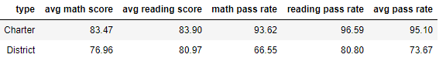

There was a trend towards schools with lower budgets having better academic performance. This was more pronounced as budget/student got larger:

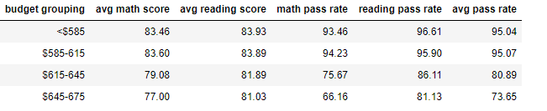

Small and medium sized schools had better academic outcomes than the large sized schools:

